React Cheat sheet

(path/ file, element, code)

* Start up:

1. come into folder in terminal
2. In terminal run: create-react-app folder_name
3. Get in to folder_name folder
4. Run: npm run start

* Path:

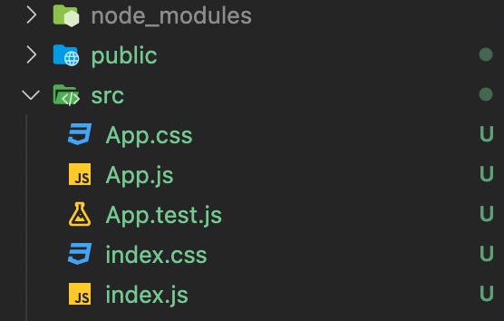

1. we create react components in App.js and export it
2. In index.js we import App.js react component and use ReactDom to render it

3. In public/index.html we have a div with its id to place the React component

* JSX (use HTML tag/code in .js file)

<Comp /> or <Comp></Comp>

* Components in React( = javascript function return (JSX code) => !return element must in a main element like a <div> )

?can I use arrow function to define a component ? Yes it works! let comp = () => {return()}

Index.js > app.js > components.js

!!! One page = index.js can have multiple app => each app can have multiple components !!!

Create components and export it export default comp=> In App.js import needed components, use JSX tag <Comp />to render then export app => In index.js import needed apps, use ReactDom to render to the right place.

* Style change

Import Css file (import ‘./x.css’)=> use the keyword className instead of class in JSX

<div className = ‘head’>

* Dynamic data

Use {} to hold dynamic data

!!! Props (transfer data between different (normally parent and child components) components

Parent: def data => transfer in JSX element through child components

Child: use props to get data then use it in {props.xxx} xxx from Parent.js

App.js => const obj = {name:’Sam’, age:12} => <Child name={obj.name}></Child>

Child.js=> function child(props) => <div>{props.name}</div> = <div>Sam</div>